**Automatically Take Screenshots on Verify Expression Success or Failure**

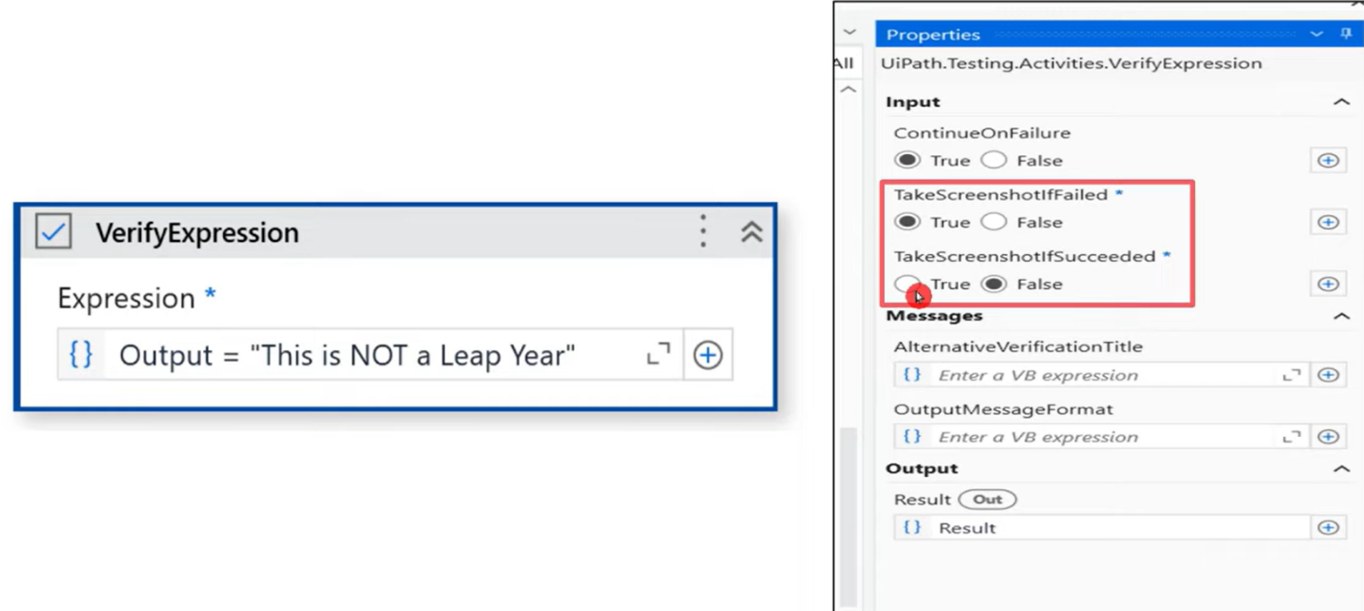

We can choose when to take screenshot, when succeeded or only when failed or both.

Once you set the above property in test case, go to your code -> project settings -> enable these 2 radio buttons

Decide where to store these screenshots, create a folder inside/outside project folder & copy it's path.

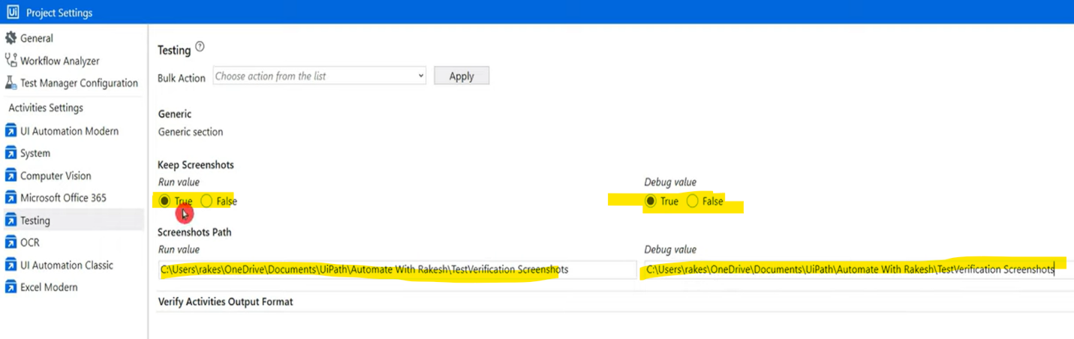

After running the code, check if this is reflecting. If you cannot see the new folder, check the filters & select "others" & refresh the tab.

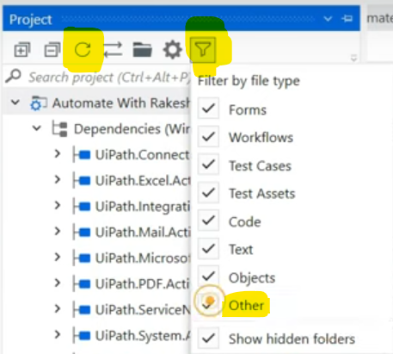

We will now see the folder & saved screenshot inside that.

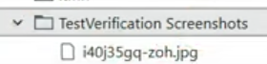

=================================================================================================================================

=================================================================================================================================

=================================================================================================================================

=================================================================================================================================

**Output Message Format in UiPath Test Verification Activities**

Can I customize output message format of verification activities.

Below is the actual format seen by default.

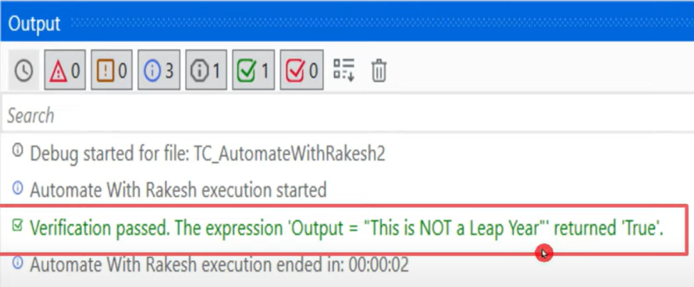

We can use the below property in the activity itself.

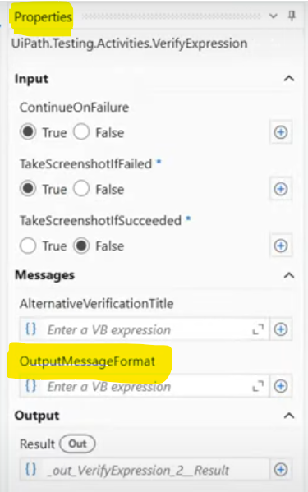

If we are using multiple verification activities, instead of setting this property in all activities, we can globally apply this in project settings.

While using this verification activity, in-built 2 variables get generated that is result & expression.

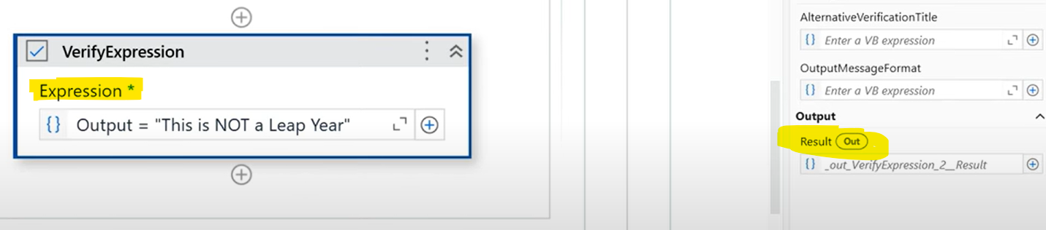

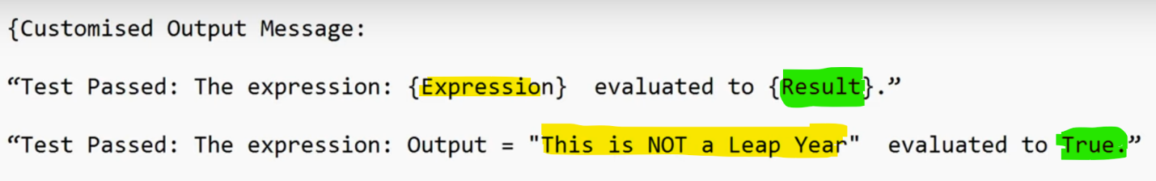

Update this in project settings & run the test case & check what output it gives.

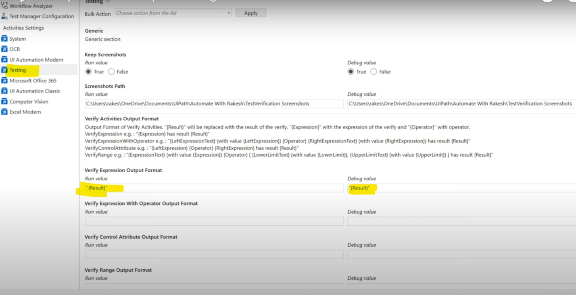

Output simply says "TRUE"

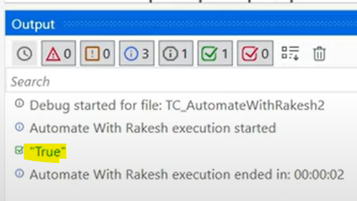

"Result" is saying TRUE, let's see what "expression" says.

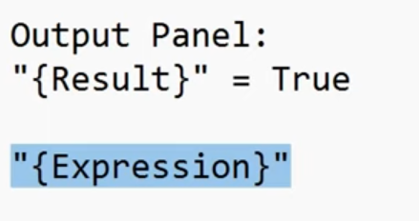

Make the below changes in project settings & run the test case.

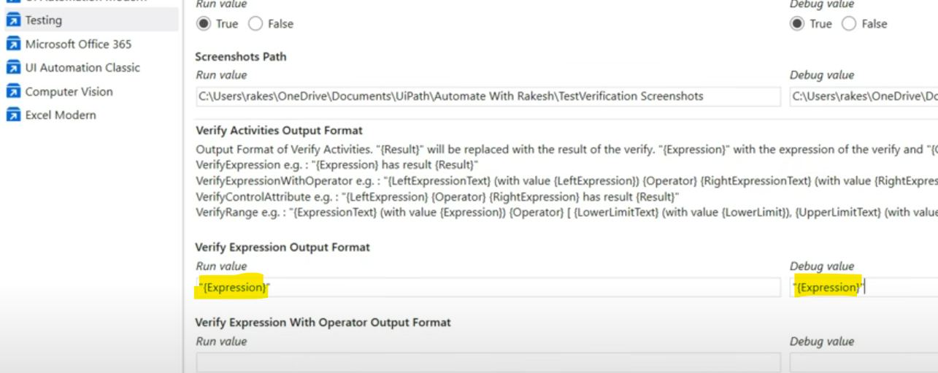

Below is the output for "Expression"

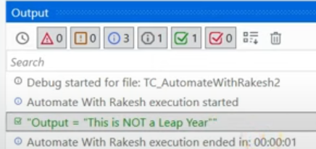

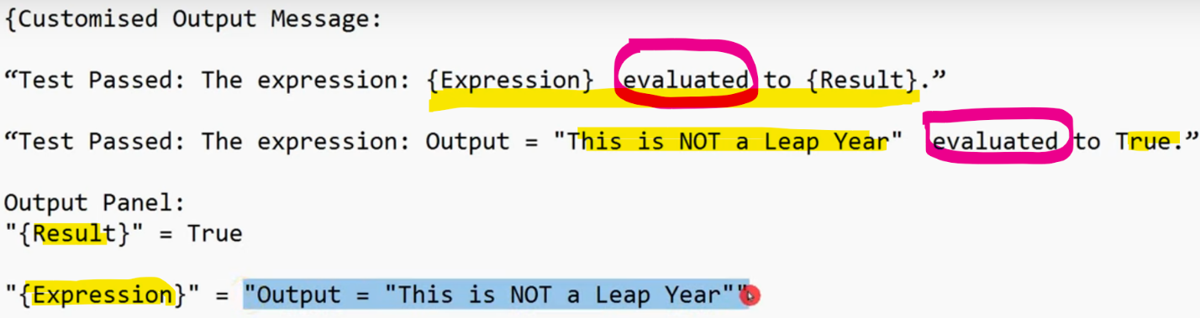

What will happen if, I write both "Expression" & "Result"?

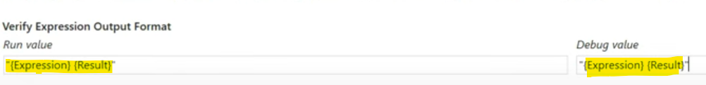

Below is the output for above expression

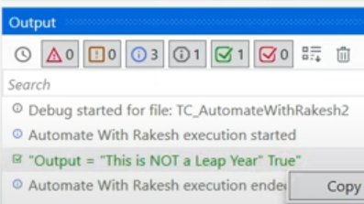

If you are using customized expression like below. You will get customized results in output.



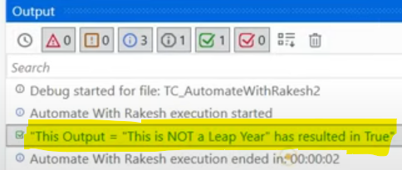

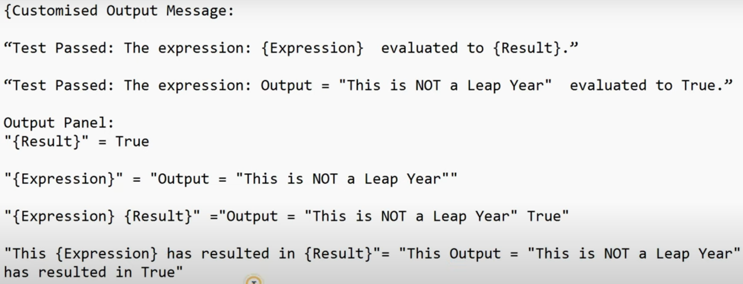

If you apply the same expression in activity property section like below, we can see same above output

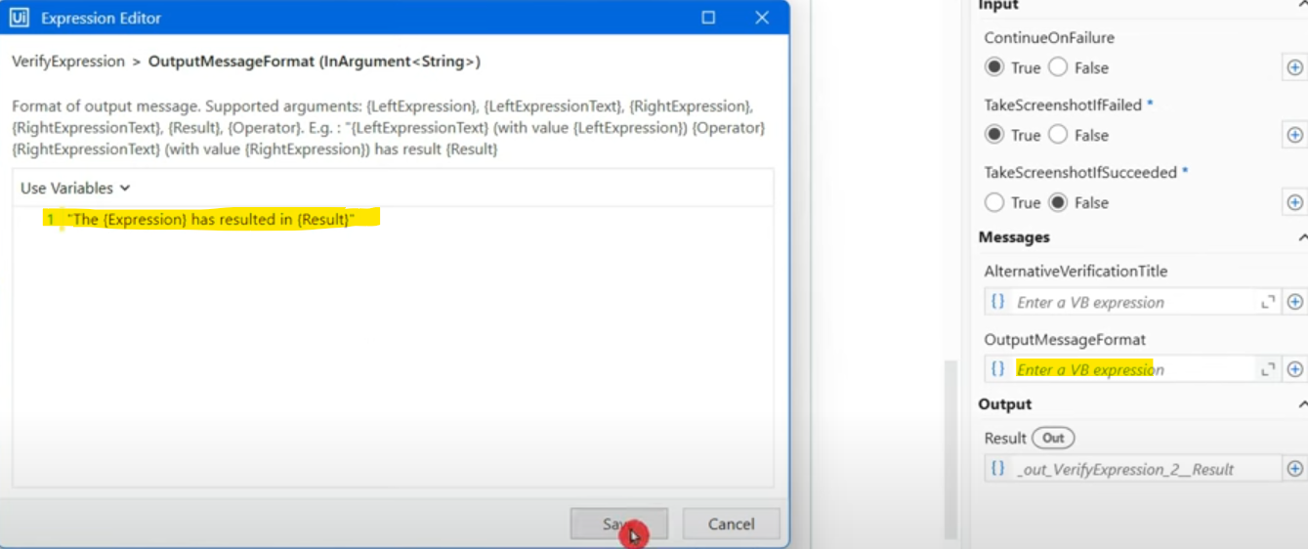

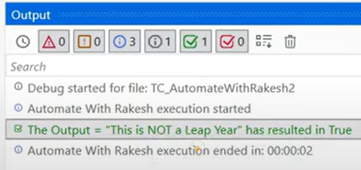

**What is the Drawback?**

Let's remove all the customized expressions from property section as well as project settings & see the default output as below for pass & fail

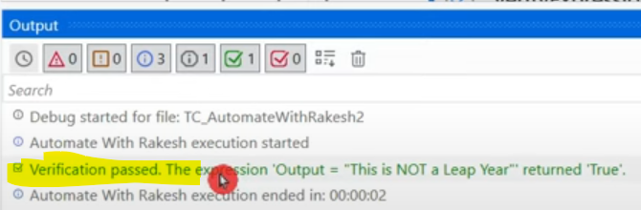

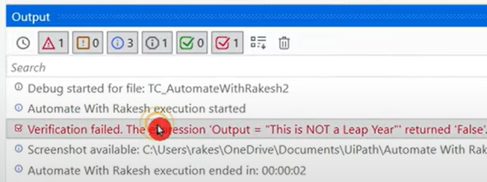

Drawback is passed/failed & colors will be missing. We cannot add keywords "passed" or "failed" with green red color in customized message.

Go with the default one but if necessary we can use customized one.

=================================================================================================================================

=================================================================================================================================

**How to Store UiPath Test Verification Output Message as a Variable?**

Whatever expression is displayed in outside is only within scope of that sequence. To store it in a variable, we can create a variable in property section "**Result**" property which is a Boolean type variable giving True/False values.

Right now there are no direct options to carry the variable value. Let's build a way to store.

Add If and update like below.

Result is Boolean so if Result is True, it goes to "Then" section & assigns the variable with the given value.

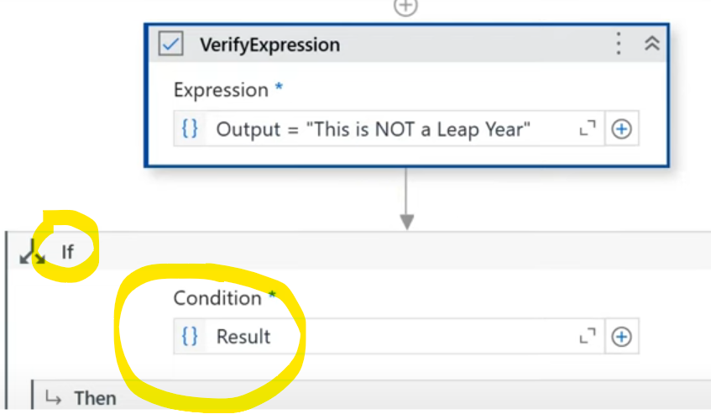

Under each "Verify expression" we can include If statement & assign output to variable.

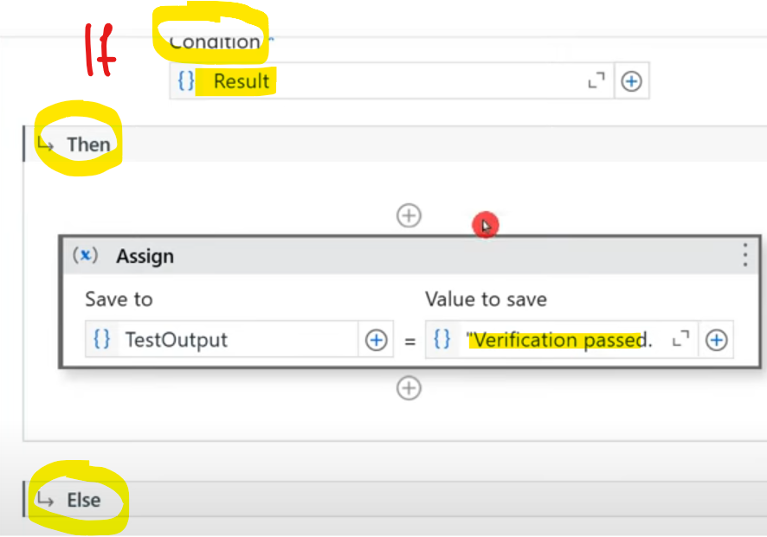

Here we have hardcoded, we can take an argument & update here instead of hardcoding.



Including a message box as well to check what is getting stored in output variable.

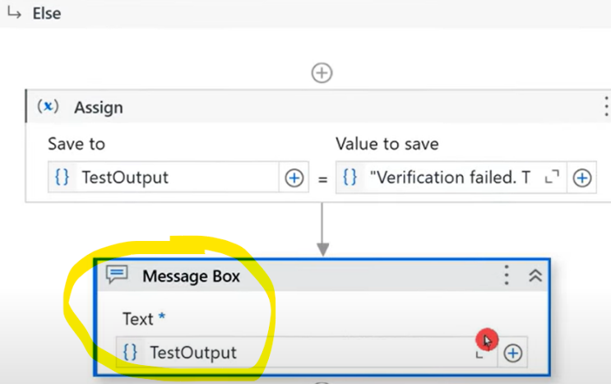

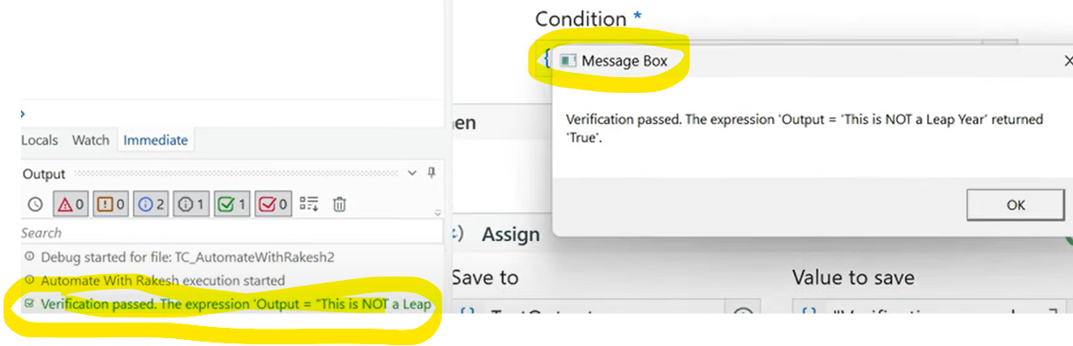

=================================================================================================================================

=================================================================================================================================

**Automated Software Testing in UiPath:**

For practice & learning purpose, Uipath has created a software for practicing Automated Software Testing.

**Link**: **uibank.uipath.com/welcome**

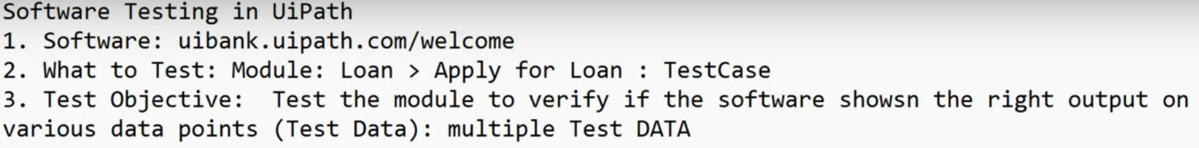

First let's understand what this software is & then proceed further with Automated software testing.

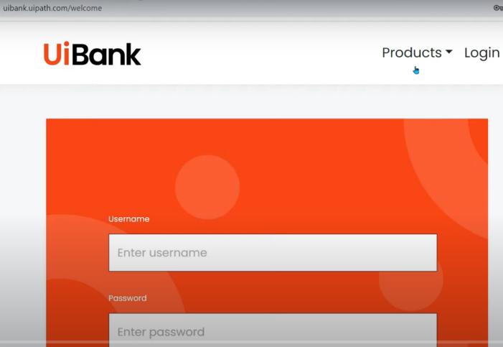

This is a bank software/website from uipath for learning & tetsing. If you do not have login credentials, register by entering required information. Login & you will see the below.

Like in a bank, we have loans, CC & mobile banking functions.

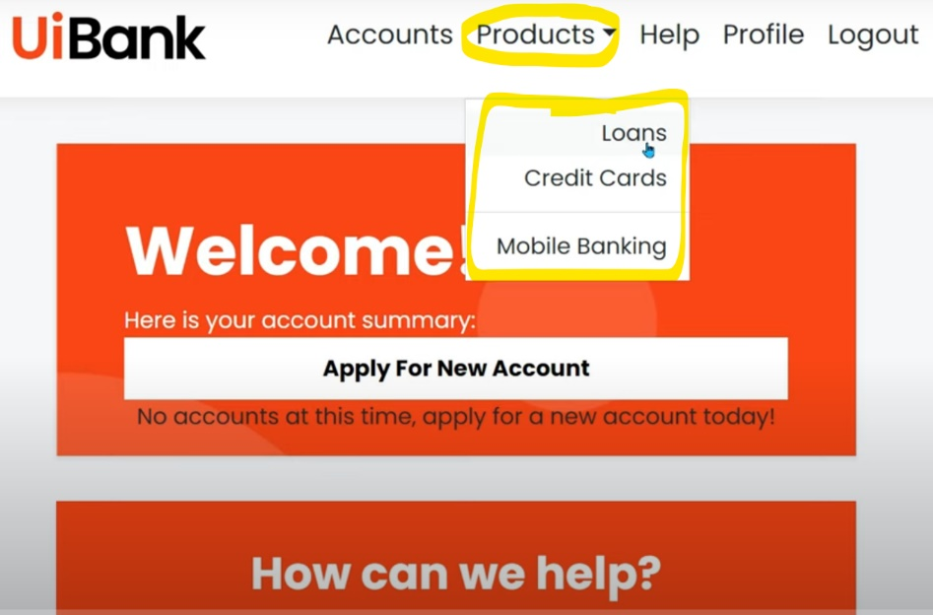

**What to Test?**

Any module/feature (Loan, CC etc.) of the software.

Apply loan feature will be tested today for our understanding.

Before testing we need to understand what the module is.

When you apply for a loan, you will get a form to fill the details and then submit the form. If I'm asking for loan 10 crore and I'm earning less, then loan will not be approved. This is seen in this software like below when age is under 18.



Based on the input, it says either Congrats or Sorry & gives other details like loan ID, ROI etc.



We need to have certain test objectives: Test the module "apply for loan" to verify if it shows right output on various data points.

**NOTE: Test case: testing modules, Test data: data entered to test the module.**

After working on 3 points, the 4th one is to build RPA project

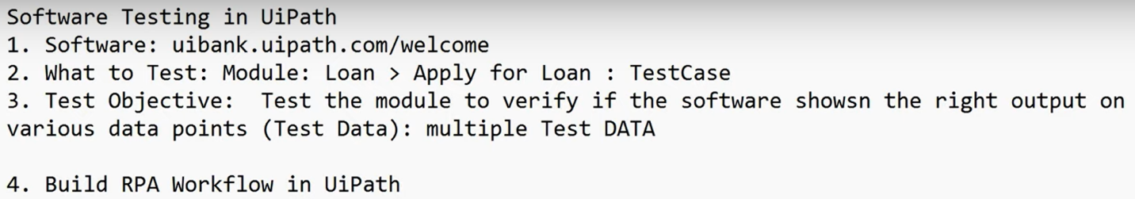

Let's create a module to enter the data for loan application & finally submit & check if output is matching.

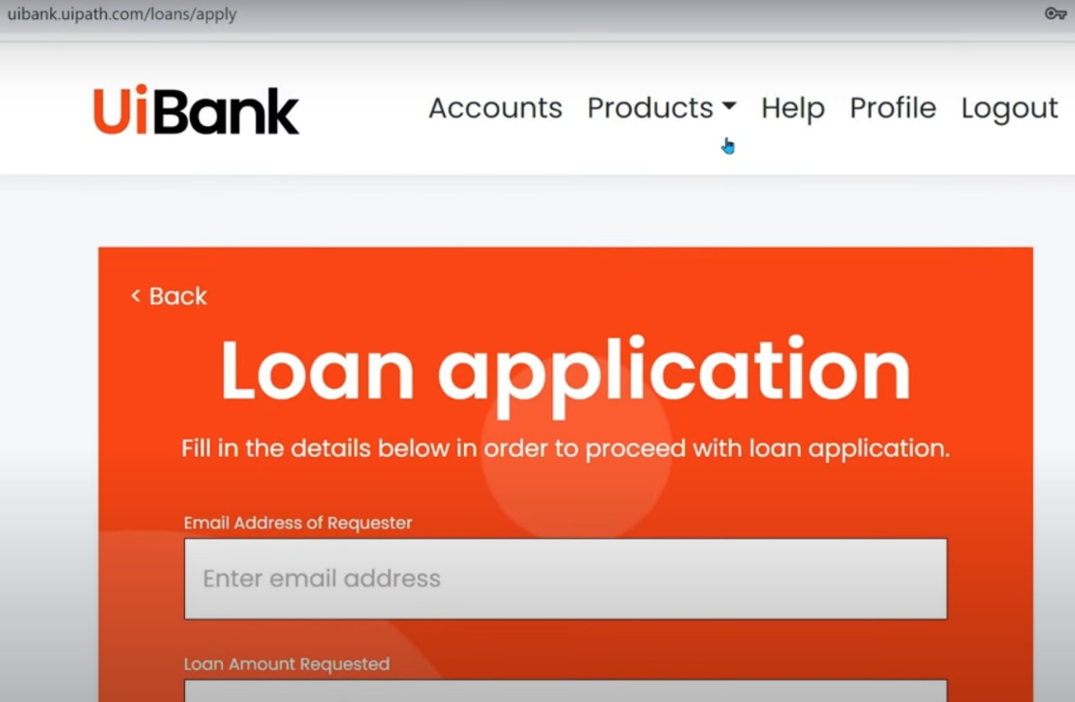

Keeping the above application open in the background, click on "app/web recorder" from studio.

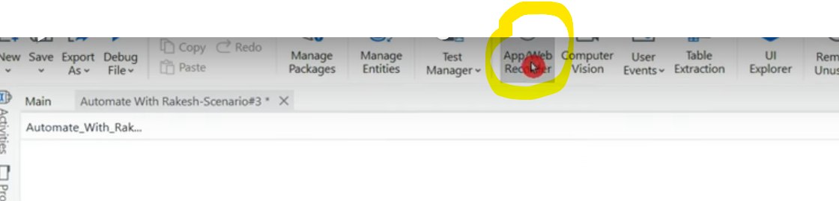

Click on Email field & we will get a popup to enter data like below. Enter & confirm.

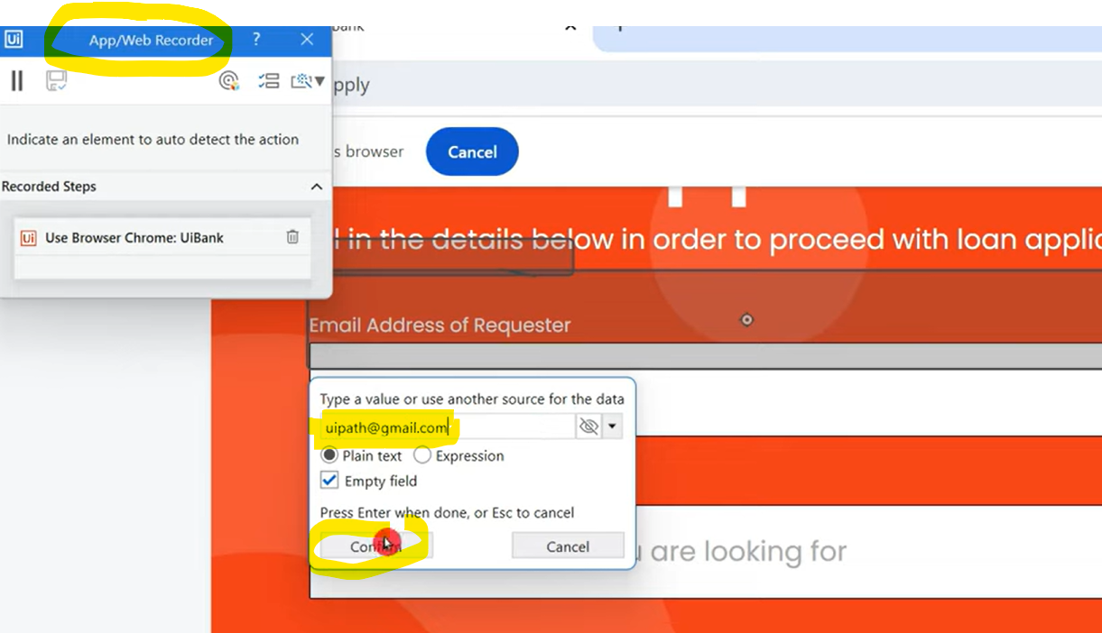

Click on next field & enter data. Also you will see the previously recorded steps by you as below.

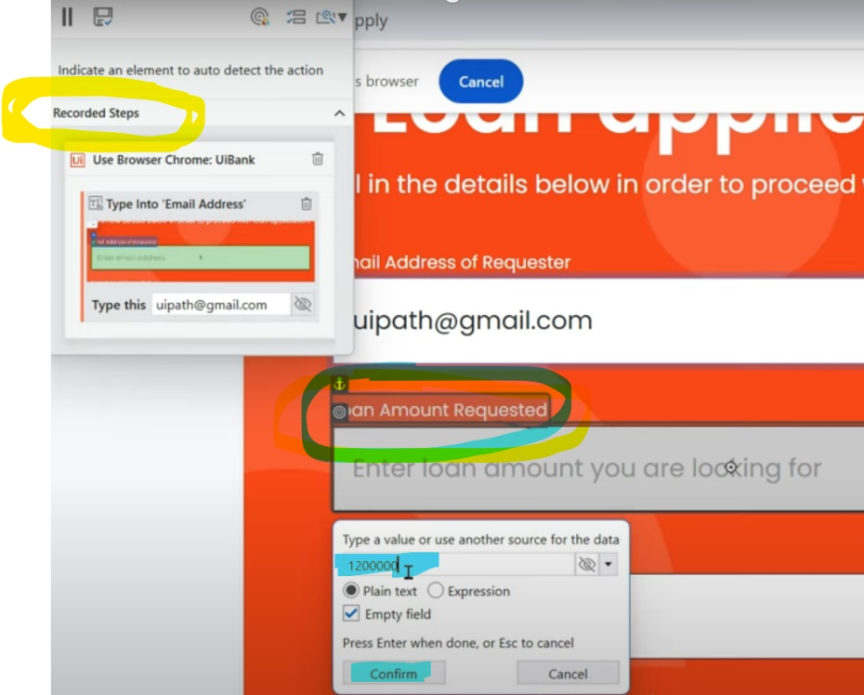

Similarly click on each field & enter the data & finally click on submit & hit SVAE button of recorder.

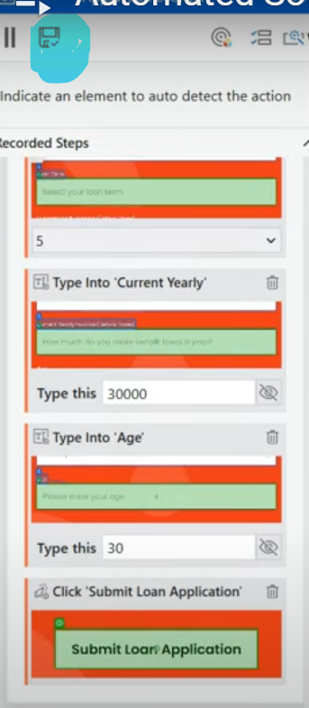

Just by doing app recording, my workflow is ready. Now it is time to create arguments.

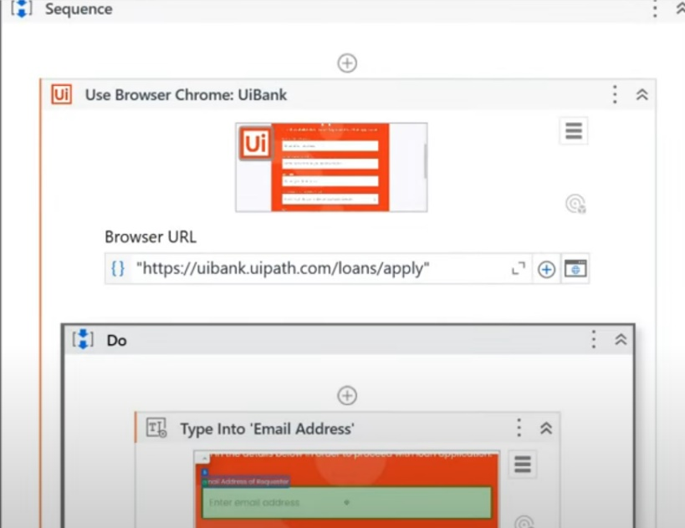

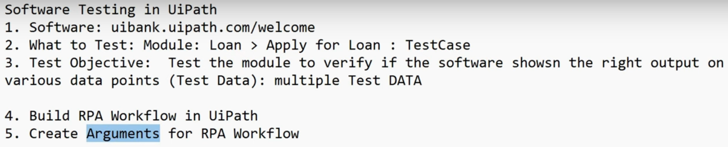

Before creating arguments, we will need test data. Navigate to UiPath academy.

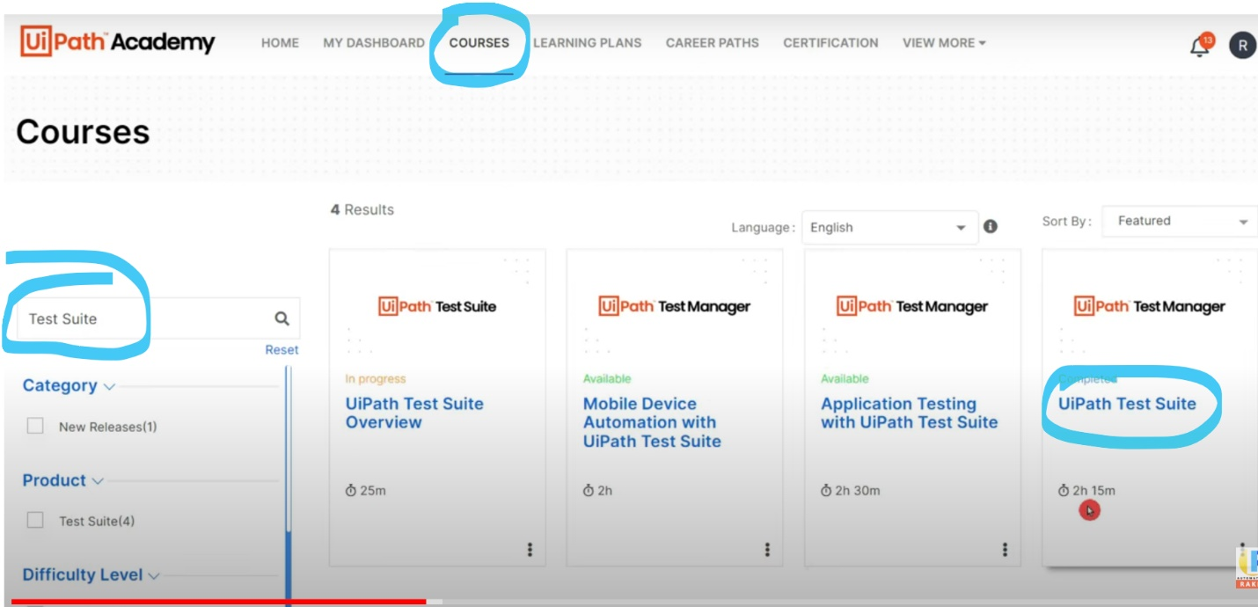

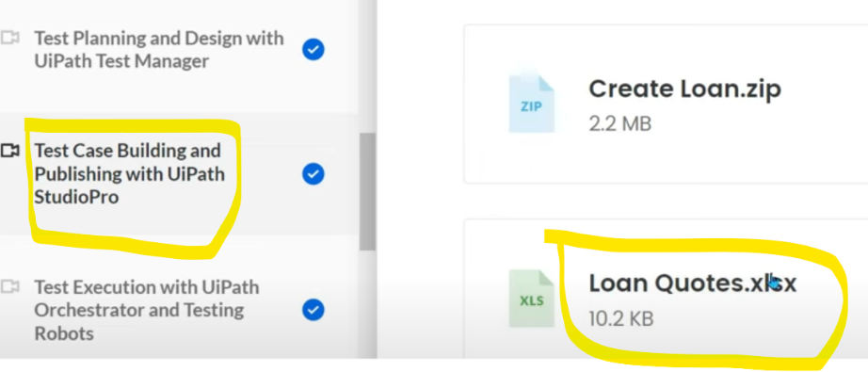

This is how the downloaded test data looks like.

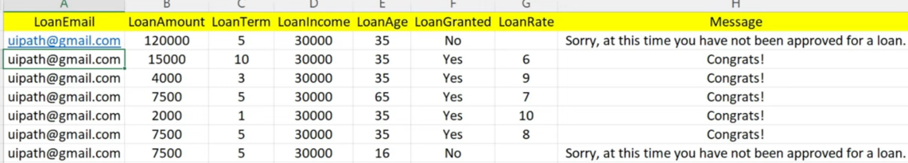

Arguments are created in name of columns like below.

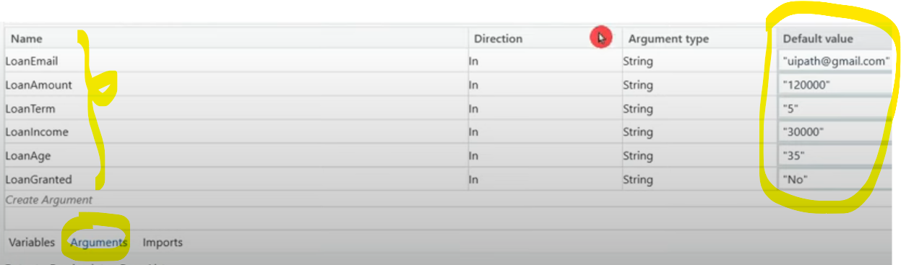

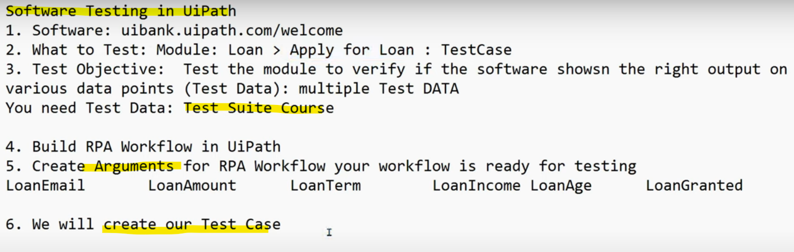

Let's test the code once before creating test case. After testing the code, if you want to verify the results in browser, it should be open for which you should select the same in property of use browser.

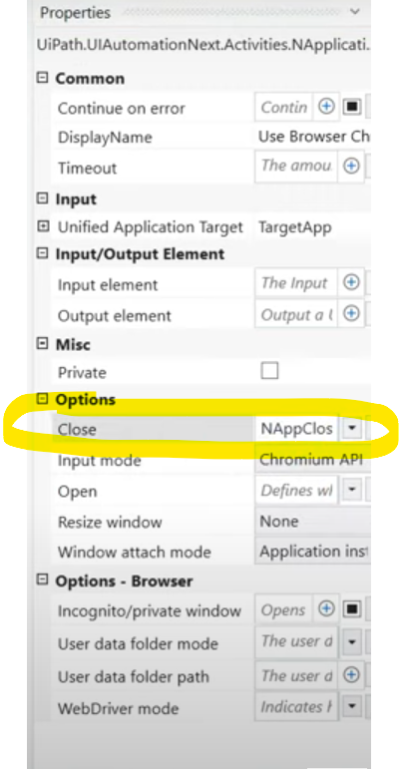

When we ran the code with hard coded value of 1st row, we got below output in chrome.



We need to verify this with the excel data below.

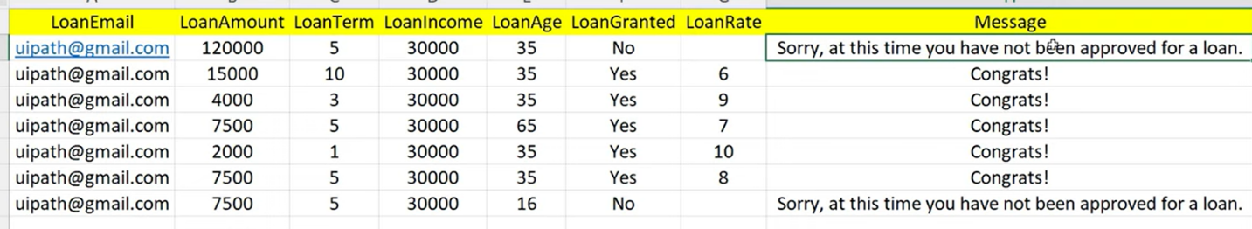

We need to test all the above data points before which we need to configure the arguments in the code because it is hardcoded when app recorded.

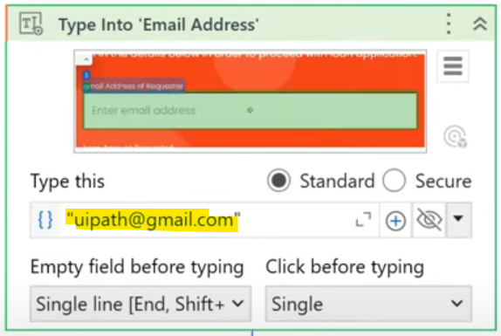

The above is replaced as below.

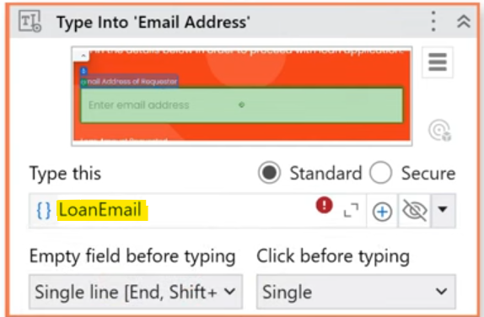

Now create test case with this xaml.

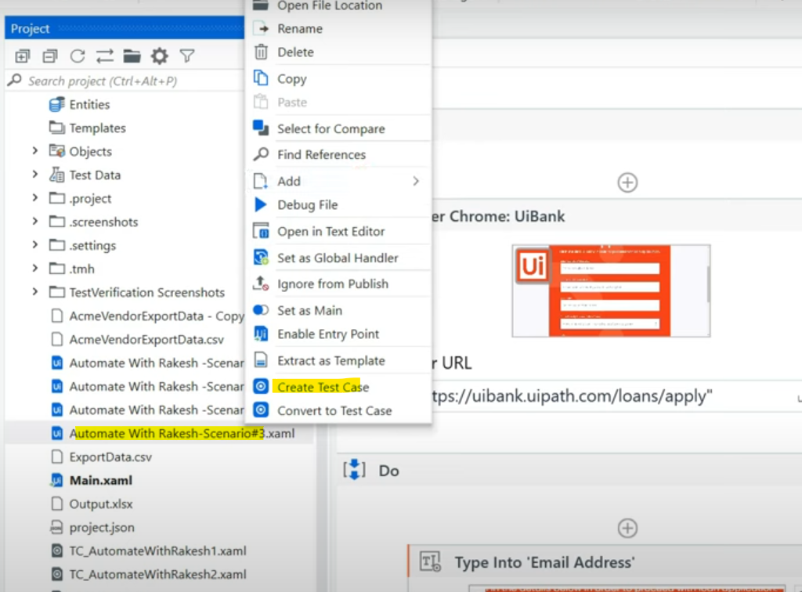

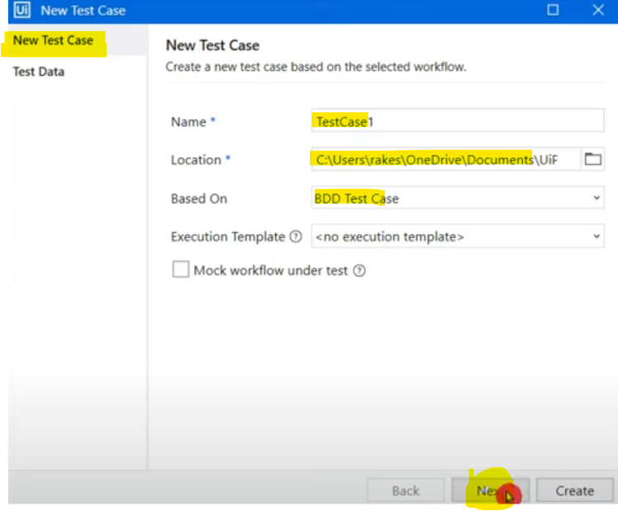

We can select or deselect the test data & create.

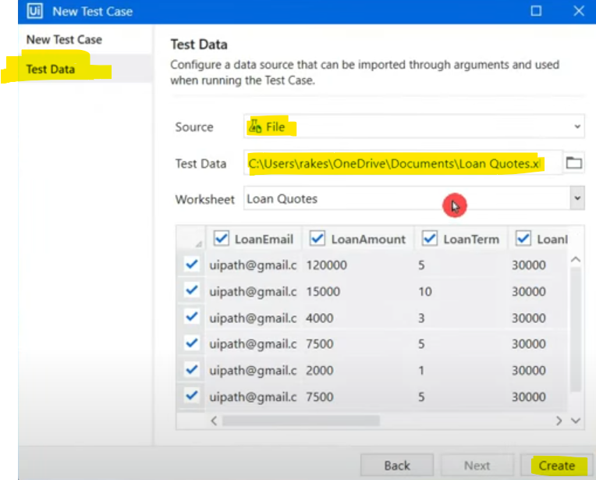

Once test case & test data are created like above, the arguments section will be filled with 1st row data by default.

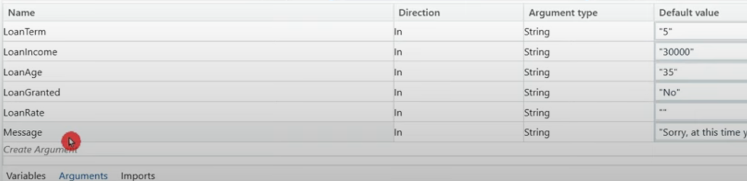

The test case "WHEN" section arguments are those which are getting reflected from our xaml code into test case.

**Value to this will be coming from excel file. As naming conventions are correctly given by us in the arguments, it is exactly matching.**

In case values don’t appear in value section, simply write.

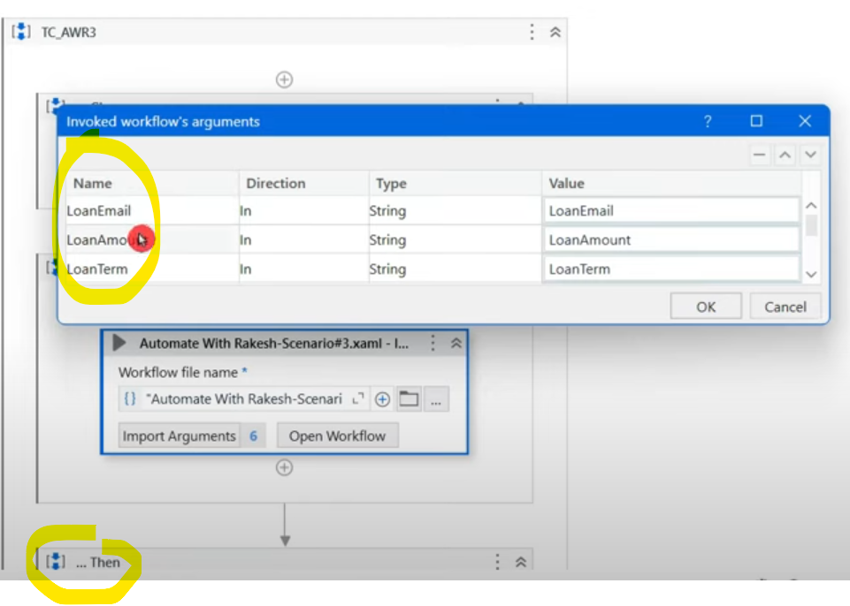

**In "GIVEN" section we no need to enter any value as test data is coming directly from excel.**

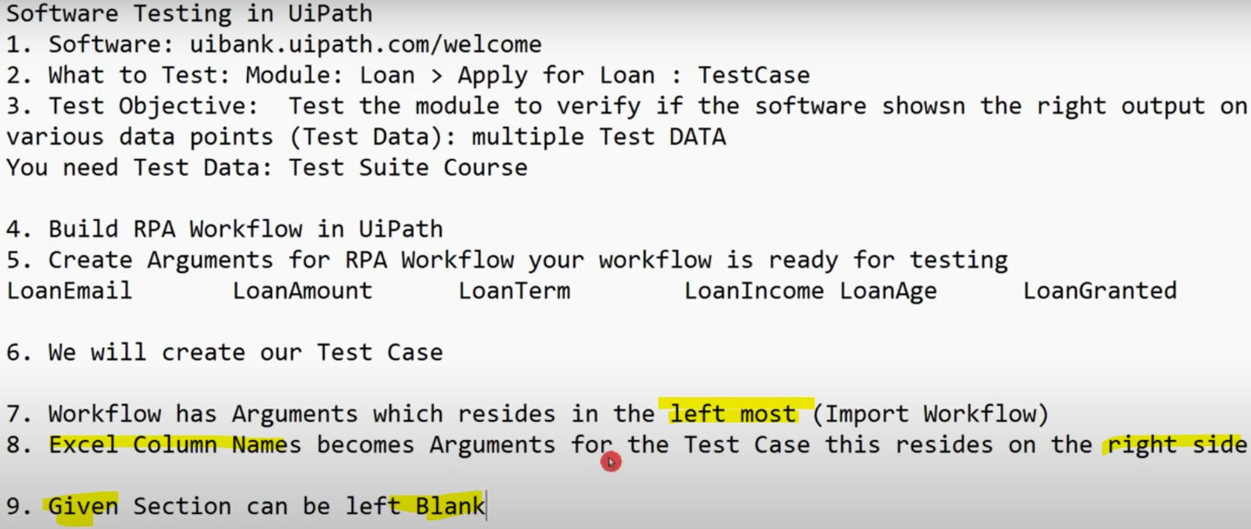

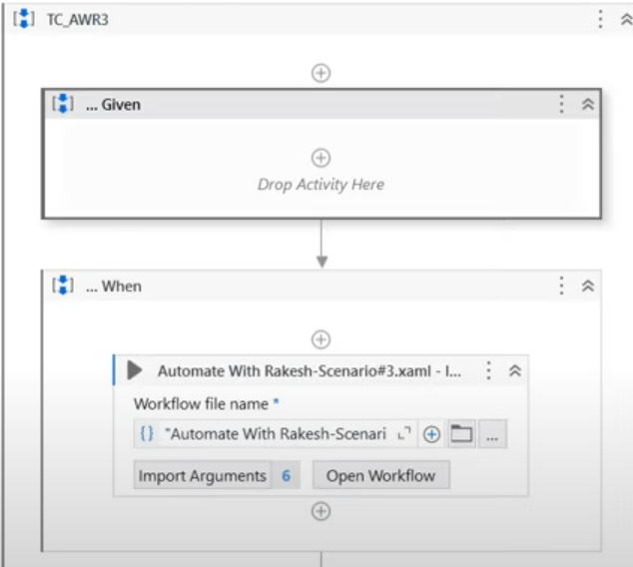

THEN section is to verify.

For verification, use "Loan Granted" column as data.

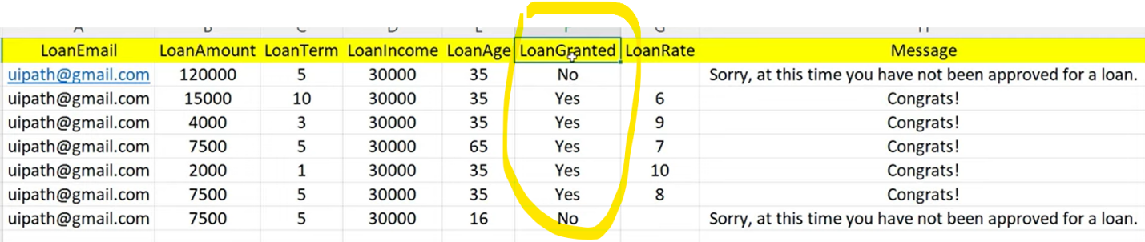

Use Browser activity & indicate the output screen.

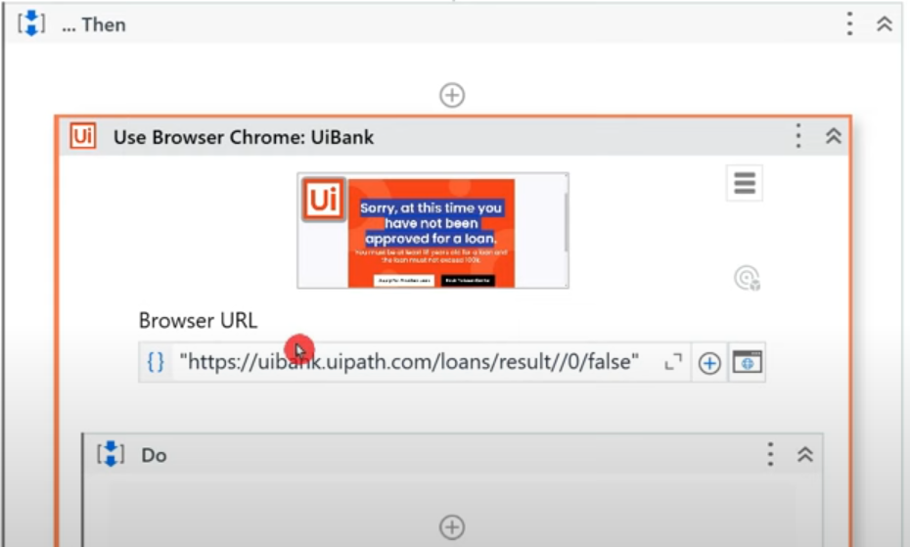

Inside browser scope, use Switch activity & change it's type argument to "string" in the property section.

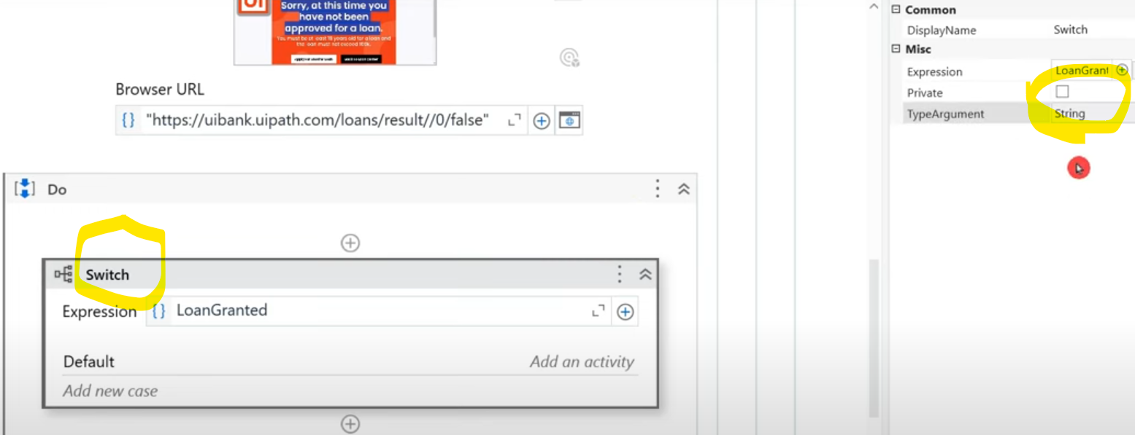

There are only 2 cases in switch - yes or No as in excel table.

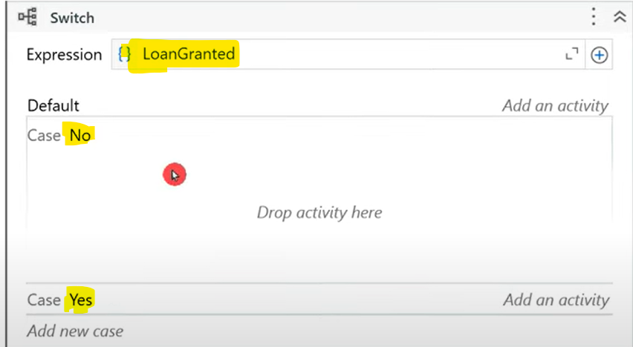

If it is NO, it means bank will have shown this below image.

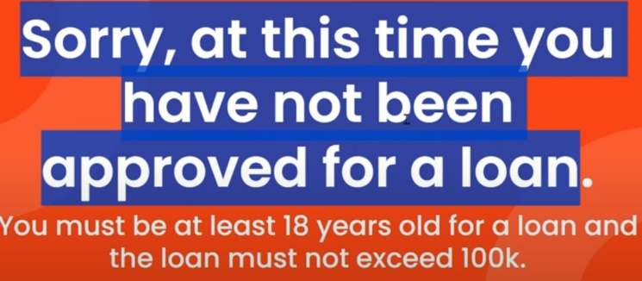

Inside NO, lets include GET TEXT activity & indicate the browser & get the attribute & then verify that with excel data.

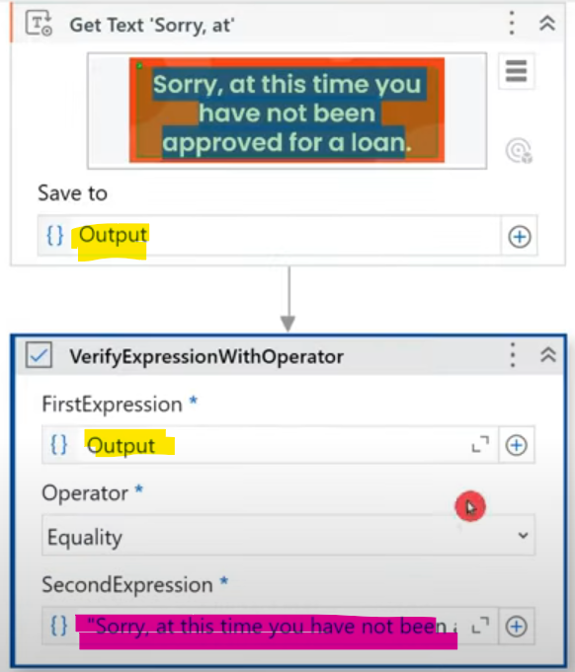

You can change the operator to "contains" and include keyword "sorry" for verification or select "Equality" & pass the exact message for verification.

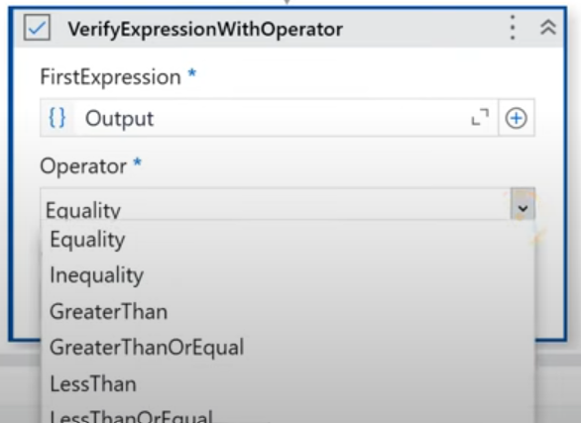

Do the similar verification to YES case in Switch activity.

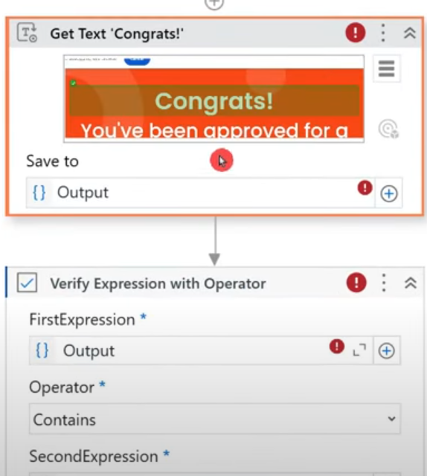

After switch activity, inside the browser scope, use click & indicate the below for new form to open to test the next data.

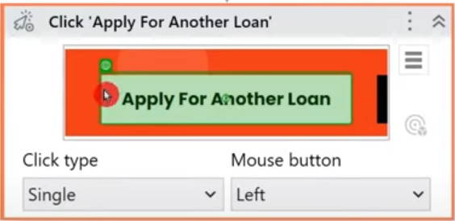

While running the test case, we find the below in debug button. Data variations means varying excel data.

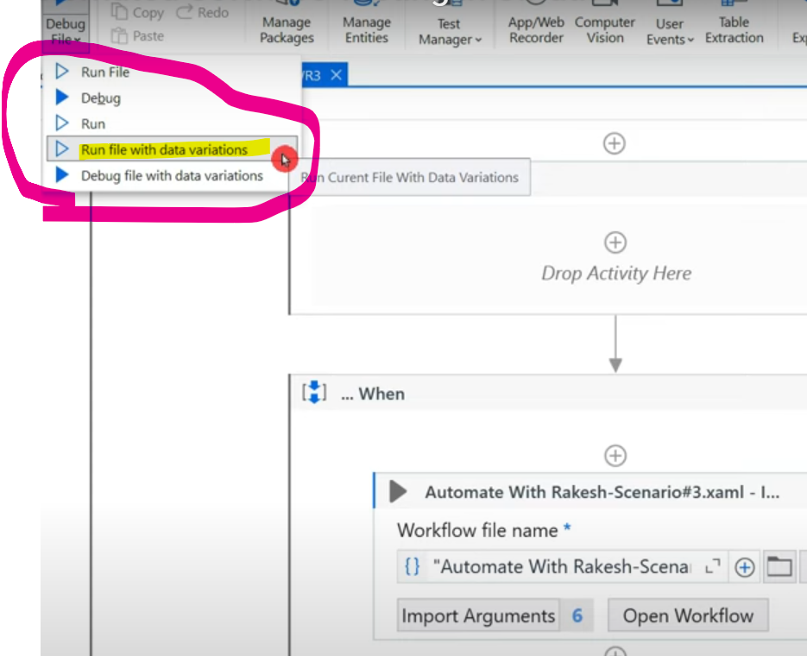

When we choose "Run with data variations", it gives us option to choose data that we had uploaded while creating test case, we can select all or which we want & click on RUN.

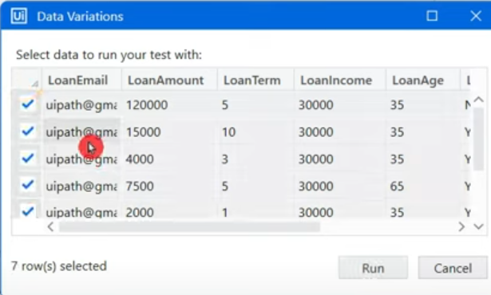

Result is displayed in output panel.

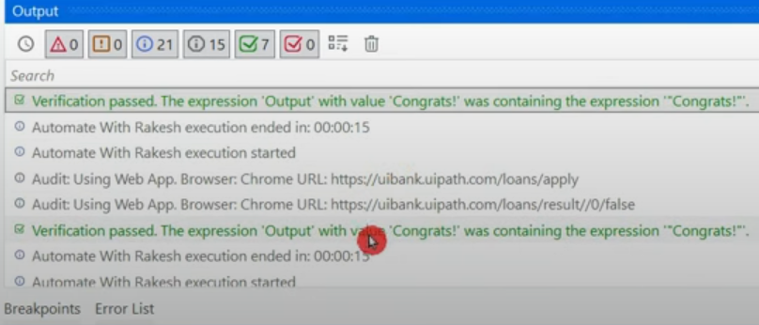

=================================================================================================================================

**Creating Synthetic Test Data in UiPath: A Guide to Automated Test Data Generation**

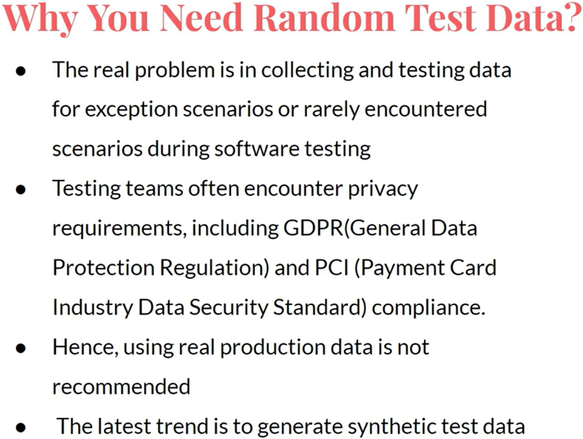

**UiPath.Testing.Activities** is the default package in studio. In case you do not have, go to manage packages & install.

Activities related to this are:

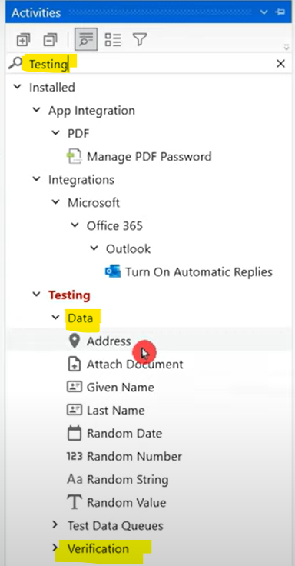

We have seen Verification related activities earlier. To create random test data, the activities are as above under "Data". The requirements are to create:

* Loan email
* Loan amount: Min 5k max 1L
* Loan term: Has limitations as in below snaps: 1, 3, 5 or 10.
* Yearly income: Min 10k and Max 60k
* Age: Min 10 and max 100

For entering the above in loan application form below

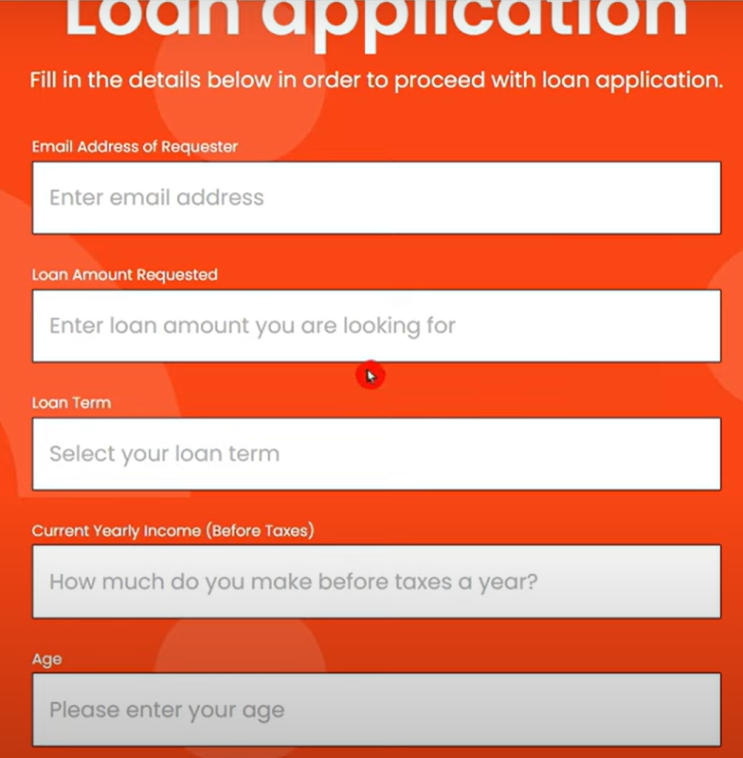

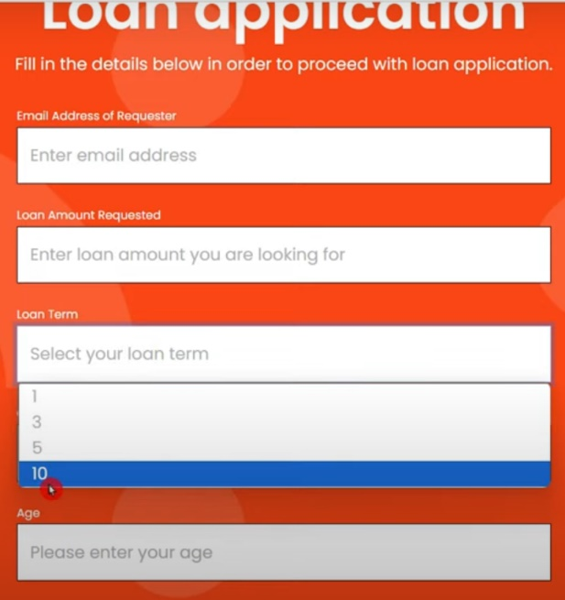

Let's use "Given name" activity to generate 1st name.

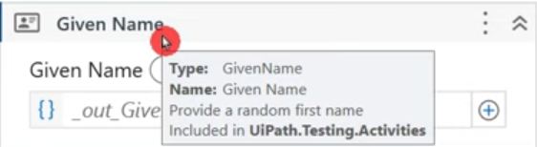

If you get a doubt on how it can create random 1st name, right click on activity & select "Help". There will be list of names filled in the backend of the activity. Activity pulls some random names out of the list included as a part of the activity.

Refer link: <https://docs.uipath.com/activities/other/latest/workflow/given-name>

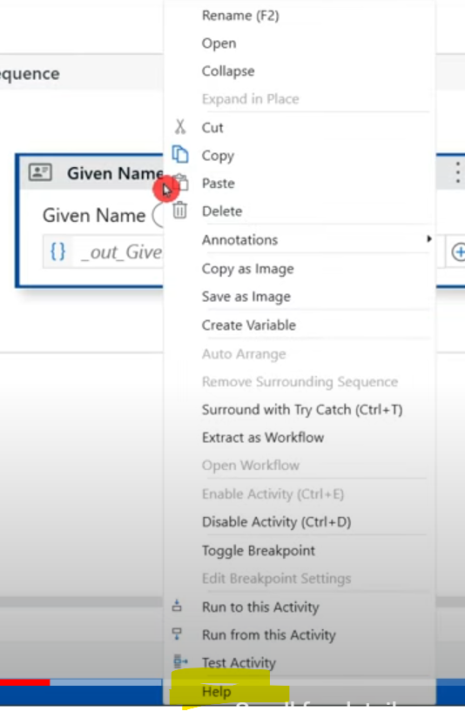

* **Loan Email:**

Create a variable "FirstName" and print the same to see how it comes.

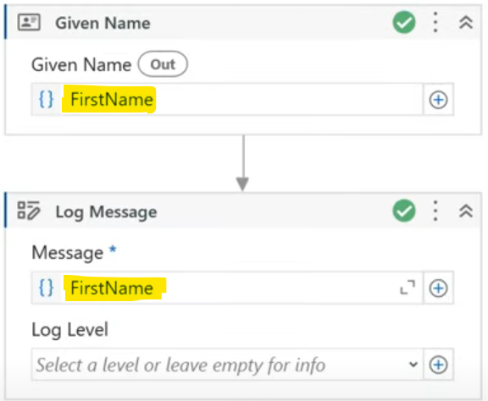

Each time you run, you get different values. Now add Last name activity. For email, concatenate FirstName and LastName with fullstop and at the end "@Test1567.com" to be added. We can add any mail id at last.

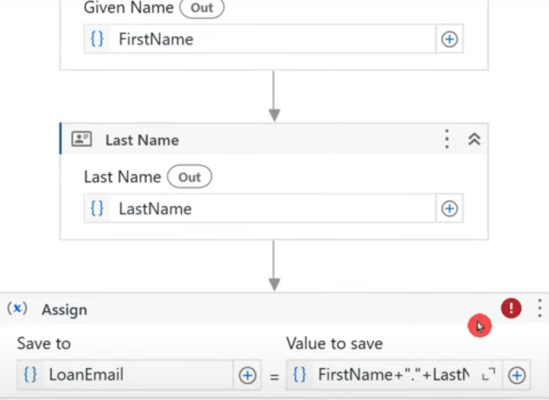



* **Loan amount:**

Mention min and max amount & create variable to store the generated value

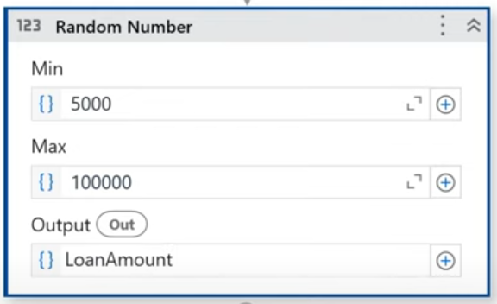

* **Loan Term:**

Only 1,3,5,10 should be generated as only these are available in the portal to select.

Let's create an array of integers with value Array={1,3,5,10}

We have to pick one out of this array so we need to generate random index (from 0-3, as only 4 numbers are present in array), for that we will write a script **Array(New Random().Next(0,3))**



* **Yearly Income/Loan Income:**

Same "Random Number" activity can be used here with min and max value.

* **Age:**

Same "Random Number" activity can be used here with min and max value.

Now we have learnt to generate all the field's data we need, next we need to add it to excel.

Place all the above activities inside while loop with below condition. **Initialize counter with 0.**

Also place "Build data table" activity by creating the column names in it to store all the above data.

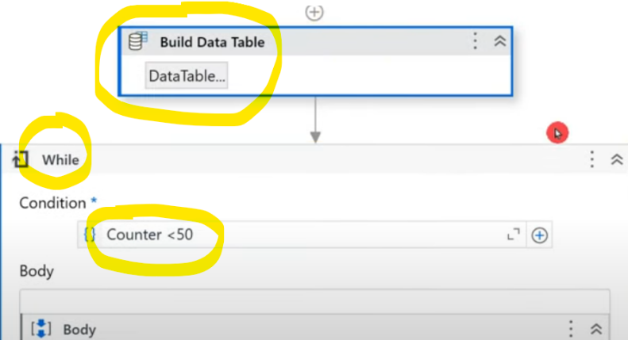

Inside While loop, after generating the field values, use Assign activity to increment counter & add the generated values to the built data table like below.



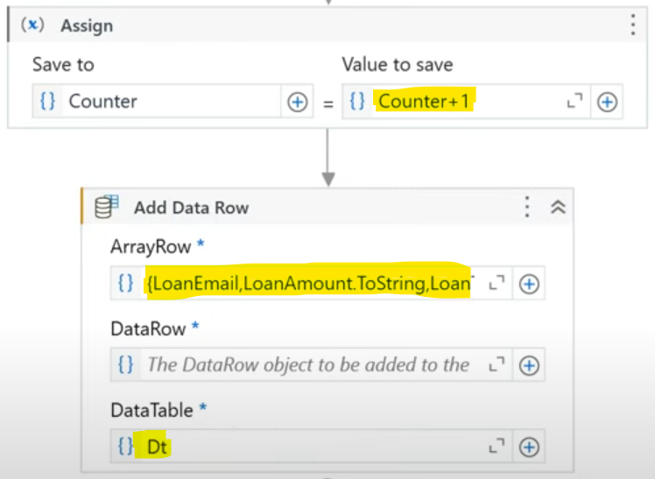

At last, write range activity to write the data table values.

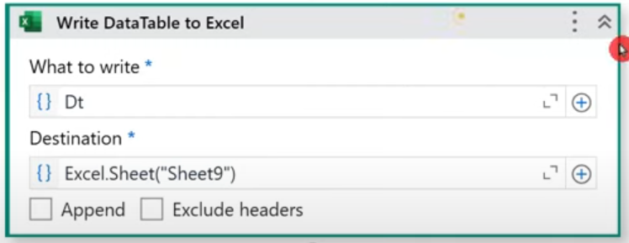

The created data looks like below.

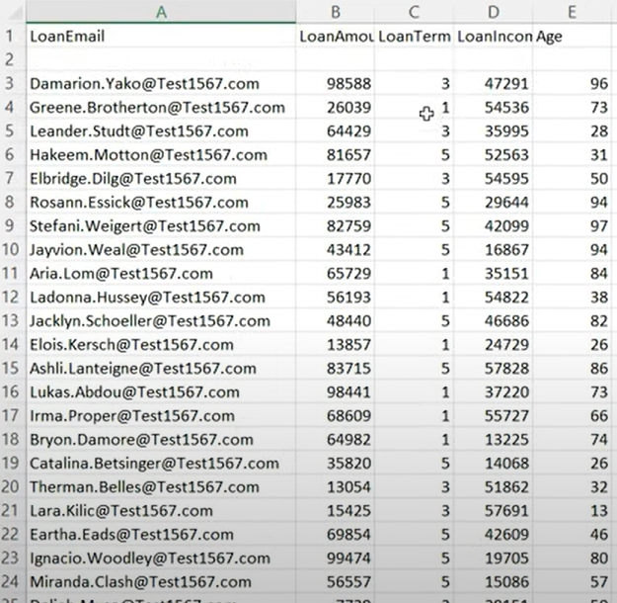

=================================================================================================================================

=================================================================================================================================

**Creating Realistic Addresses in UiPath: A Guide to Synthetic Data Generation**

Sometimes, requirement will be to add address in a single block or separate blocks like below. How to fulfill both the requirements is what we will learn here.

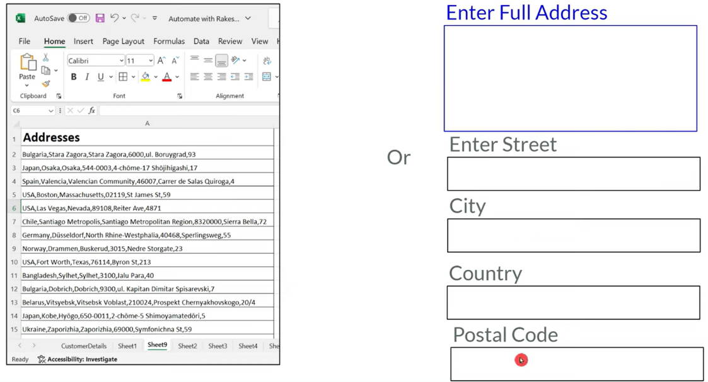

To generate Address, what activity we use?

Address activity is a part of Testing activities. **You can select any country & any city from the dropdown. If left blank, it will automatically select from dropdown & form you the address.** Create output variable to store this.

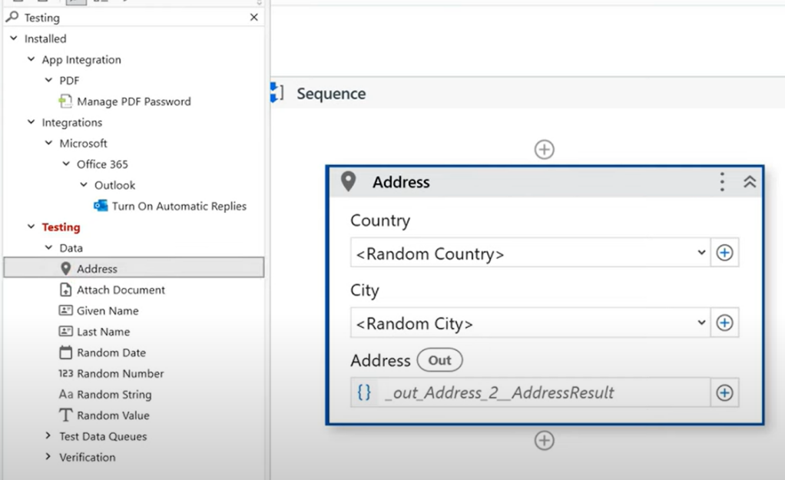

If you simply print the output "RandomAddress" we will not get any value because it is of type dictionary. We need to see what is there in the dictionary. Right click on activity & click on Help. It navigates to the page <https://docs.uipath.com/activities/other/latest/workflow/address>

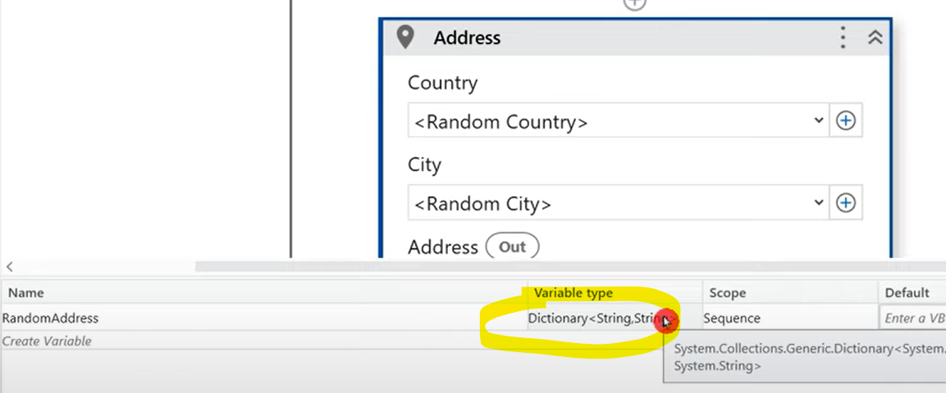

Different keys available in this dictionary are Country, PostalCode, StreetNumber, StreetName, City, State. Charset: Unicode

To access the values we need to log in the format **varAddress("Key")** like RandomAddress("Country") or RandomAddress("PostalCode")

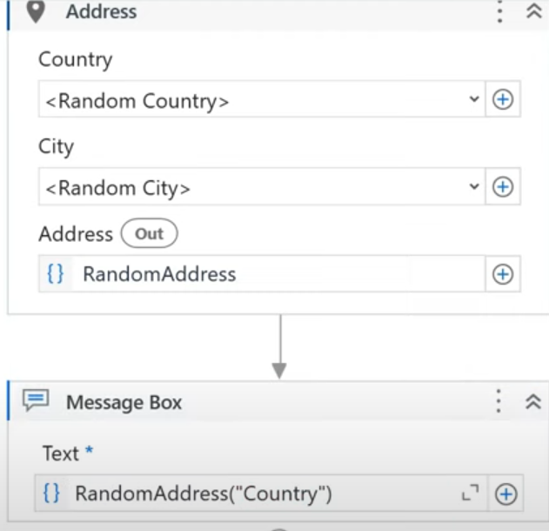

To generate entire address, we need to call all the keys of the dictionary output like below in the required format.



=================================================================================================================================

**Data Driven Test Cases in UiPath | Update Test Data, Auto-Generate & JSON in Data Driven Test Cases**

How do you create test case?

Right click on xaml -> create test case -> enter the details -> to add test data, you will find multiple options like below.

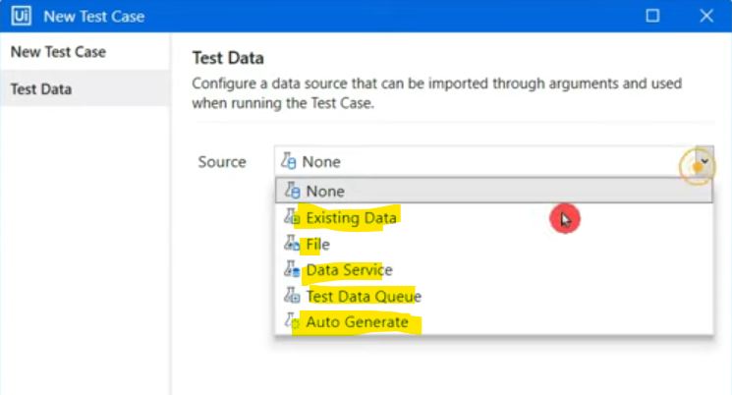

Let's say you will upload file with limited data & after certain point you feel to get more such data, how do you update the test data? Suppose below is my file & we need to add/update more such data in remaining rows.

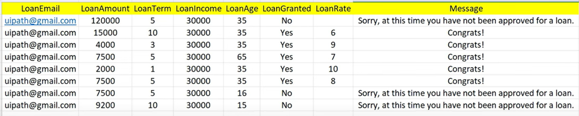

Go to the test case which you are using -> right click -> Update Test data.

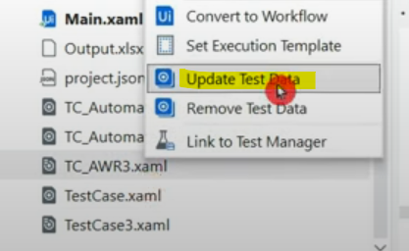

It shows the existing attached data of that test case. 1st word is file name joined with sheet name by "_". In my file, both have same names.

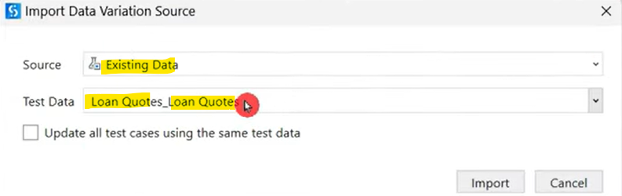

If you want to import new file, you can select from drop down & pass the path like below.

If my project has many test cases & you want to use same data for all those, we can check the checkbox below.

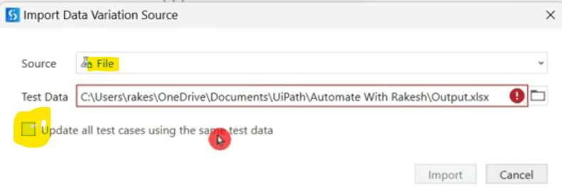

If you want to auto generate the data with the format of existing file, the file will already be added to the test case & if you click on update test data -> auto generate, below appears.

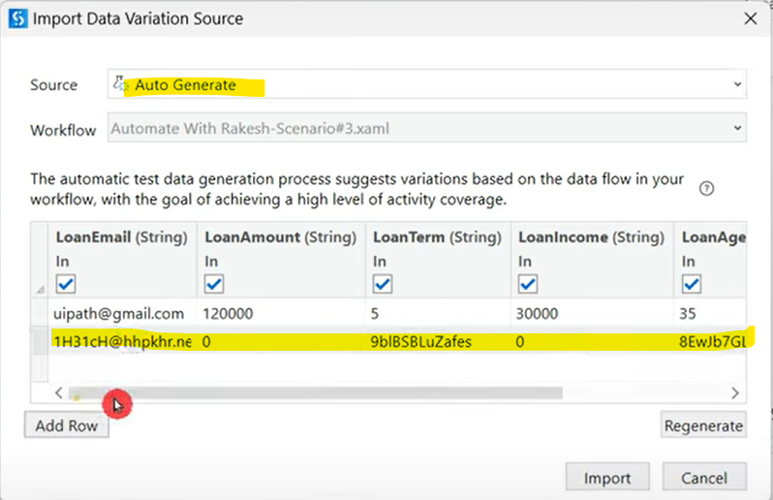

But here, the realistic data is not getting generated as we can see in above 2nd row.

If you import a file in test data, a json file gets generated under "Test data" in project folder. The number of files you uploaded on test data option will appear here. Refer: <https://docs.uipath.com/studio/standalone/2024.10/user-guide/data-driven-testing>

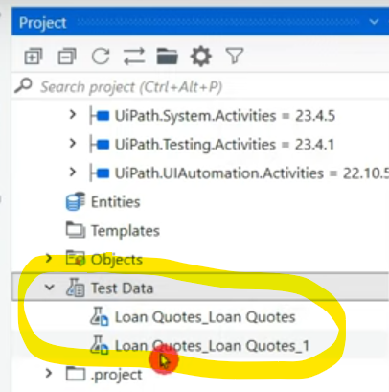

Double click on this json file & code editor will open like below.

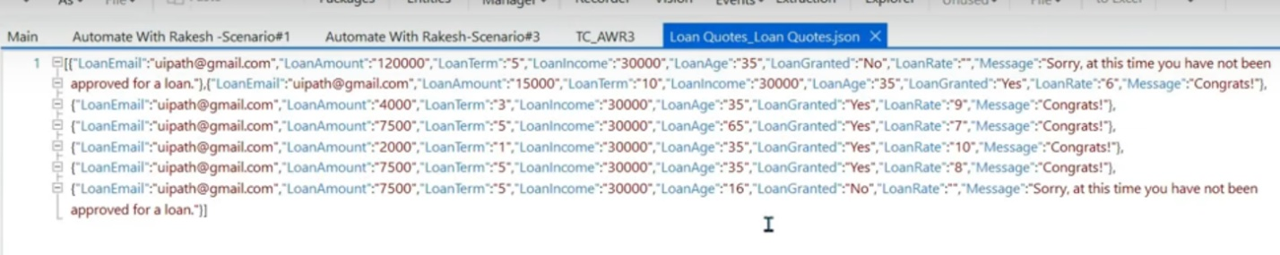

You can simply edit the test data & save it or try to close & you will get popup for save like below. This is another way of updating certain values in our test data.

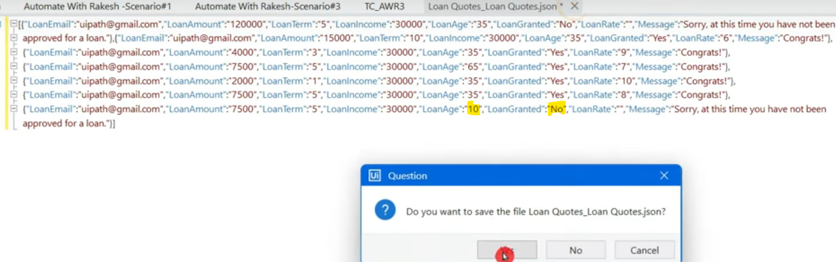

To remove test data, right click on test case & select remove test data.



